DUAL BOOTIN EXERCISE

Create a document with screenshots to explain the answer for each exercise

1. Create a virtual machine with two operating systems, Windows 7 and Windows 10 (in this order). Choose Windows 7 as the default operating system, which will boot after 5 seconds unless Windows 10 is manually selected.

We are going to start creating a new virtual machine for Windows 7 with 4GB of RAM and 70GM of memory.
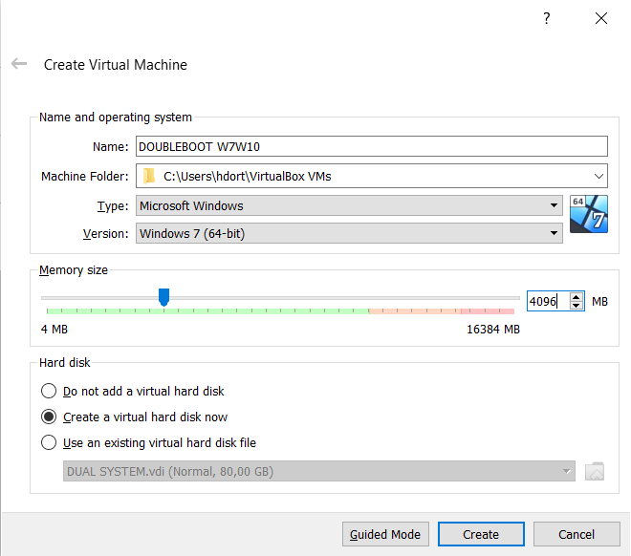
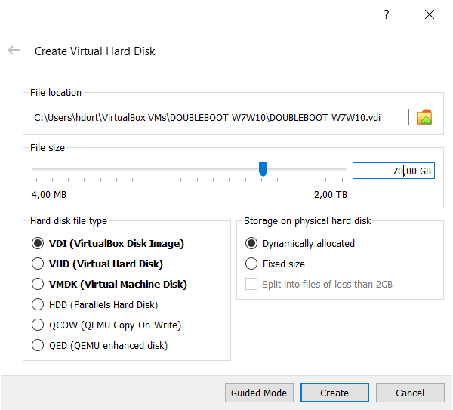

- Select Windows 7 (64bits), in order to installed.

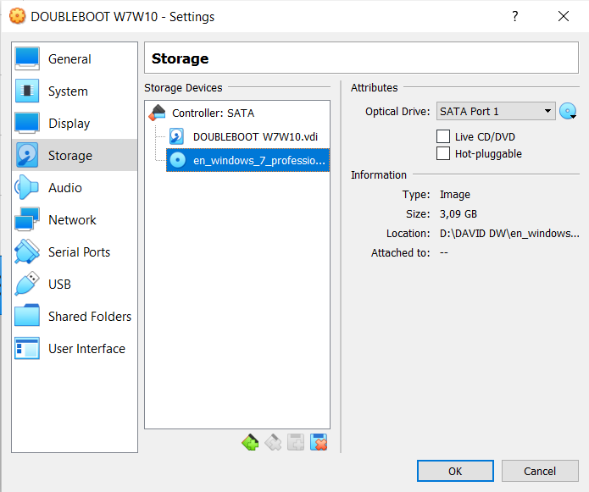
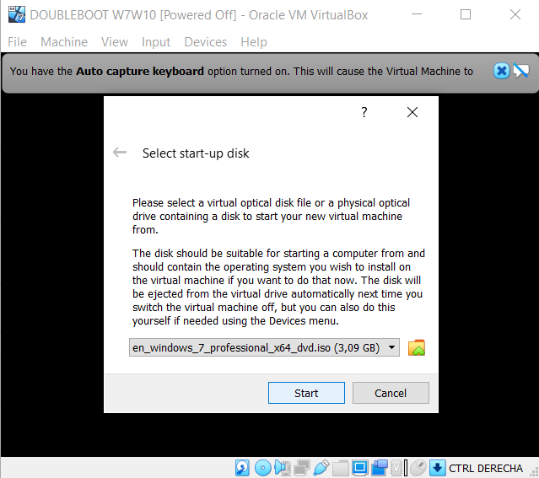

- As usually we have to configurate the operating system, we selected the laguage an the right keyboard, in our case a spanish one.
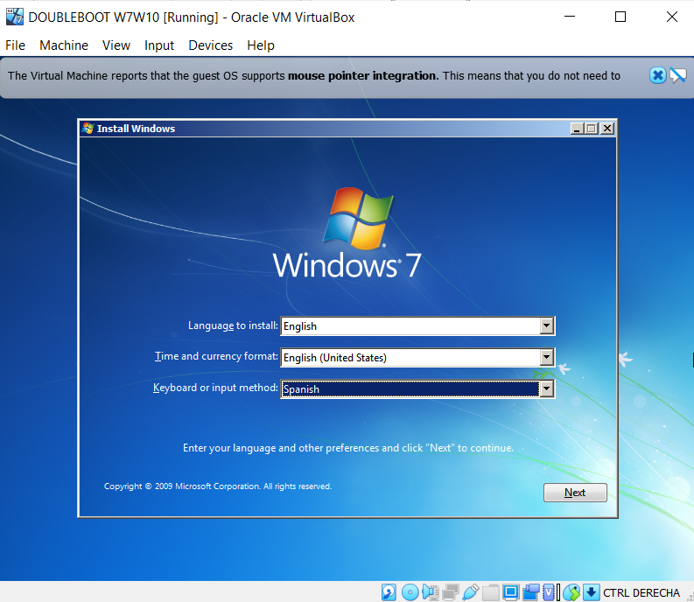
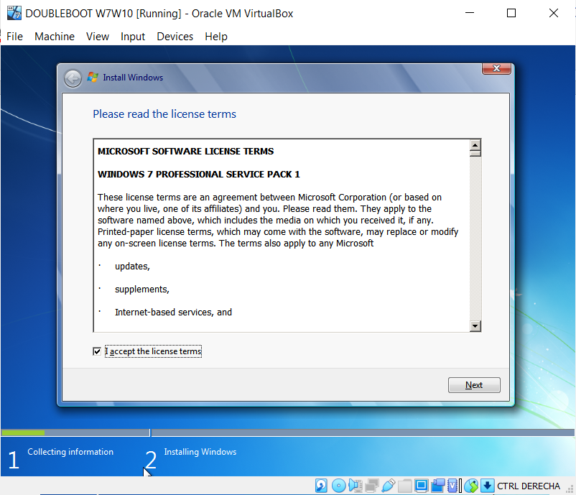
- In the next screen we have to create two partitions in order to have one partition for each OS.
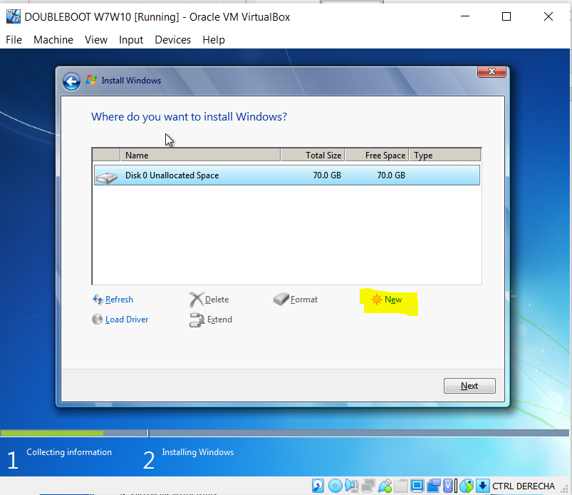
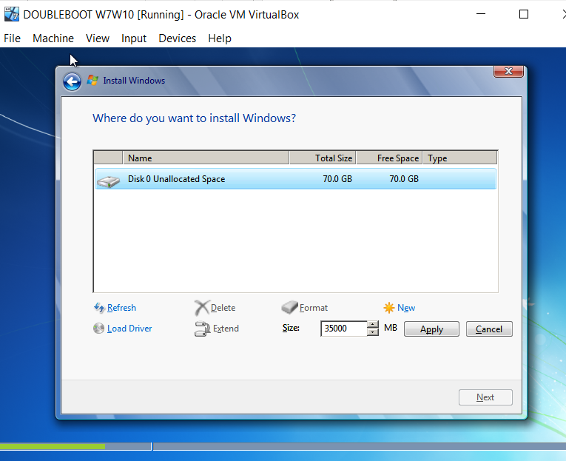
- Here we must to choose the size for each partition.
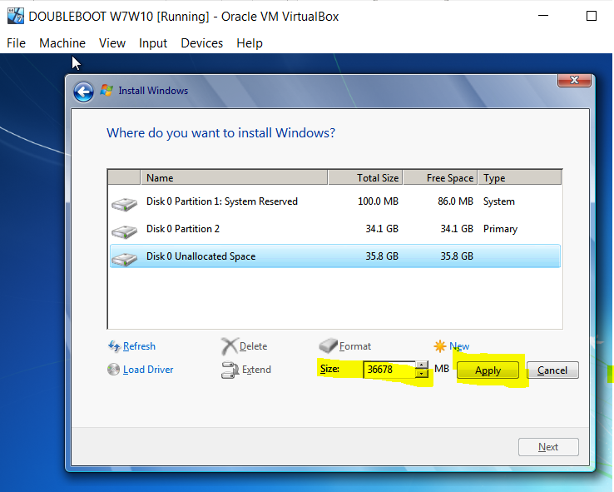
- Then we have our patitions:
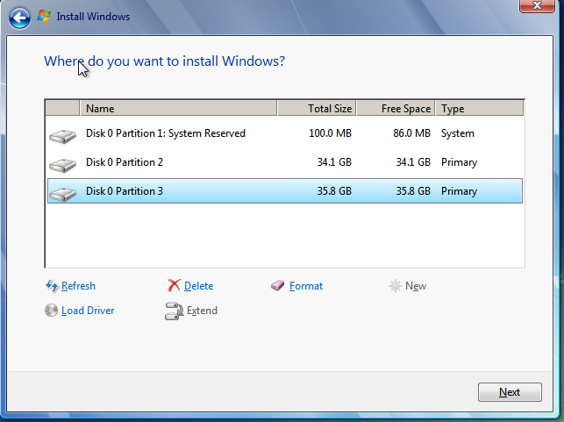

-In this point we have to continue with the installation as normaly do. And we finally have our Windows 7 installed.
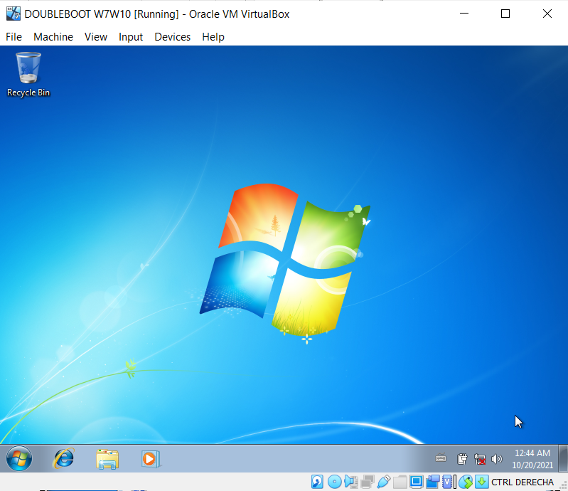
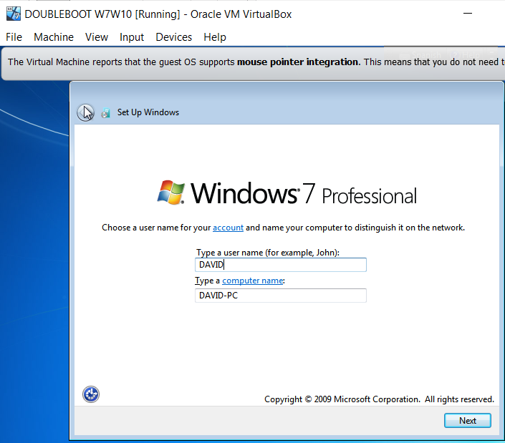

Now we have to change the cd to install the Windows 10.:
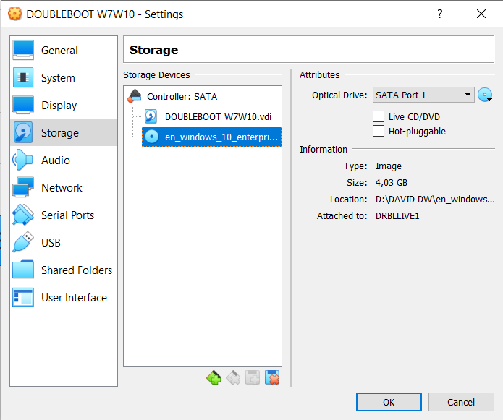
In this point we have to install Windows 10 as usually we do:

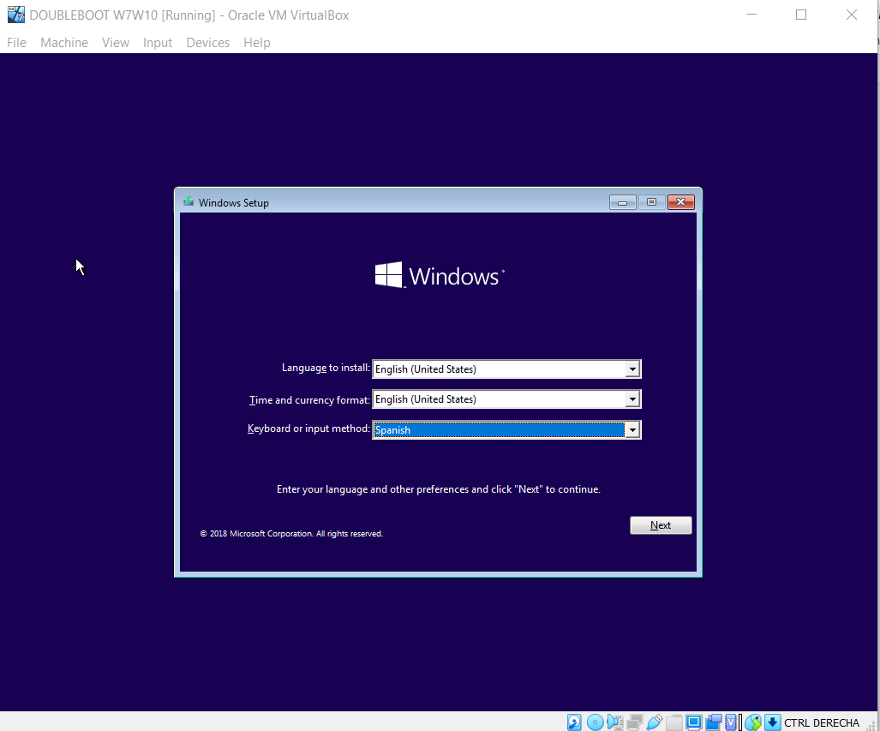
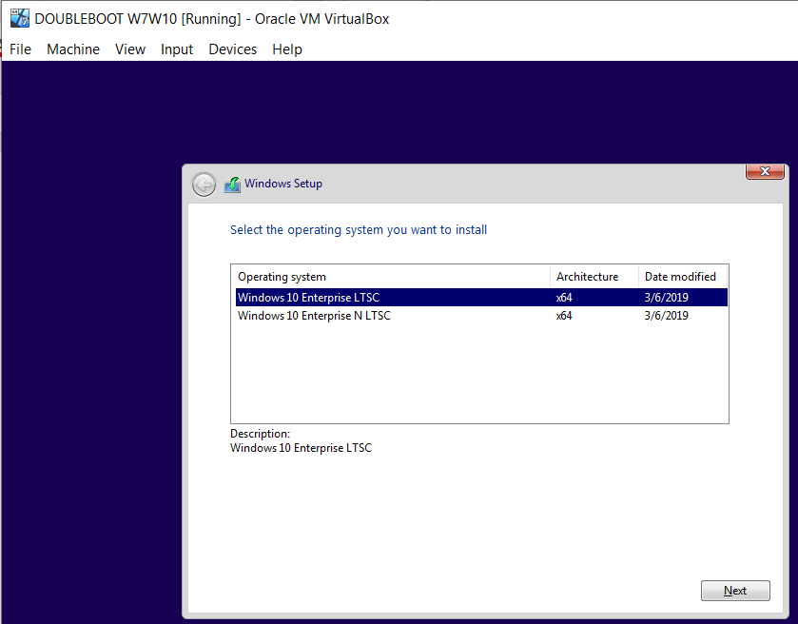
- Selecting the drive 0 Partition 3 to install it:
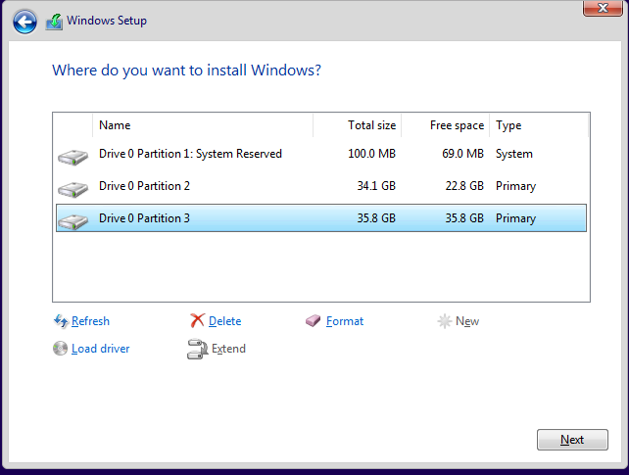
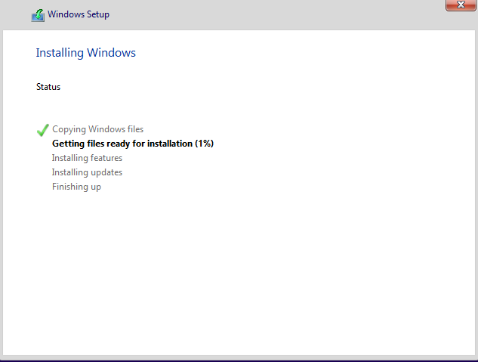
- Now we have both operating system installed:
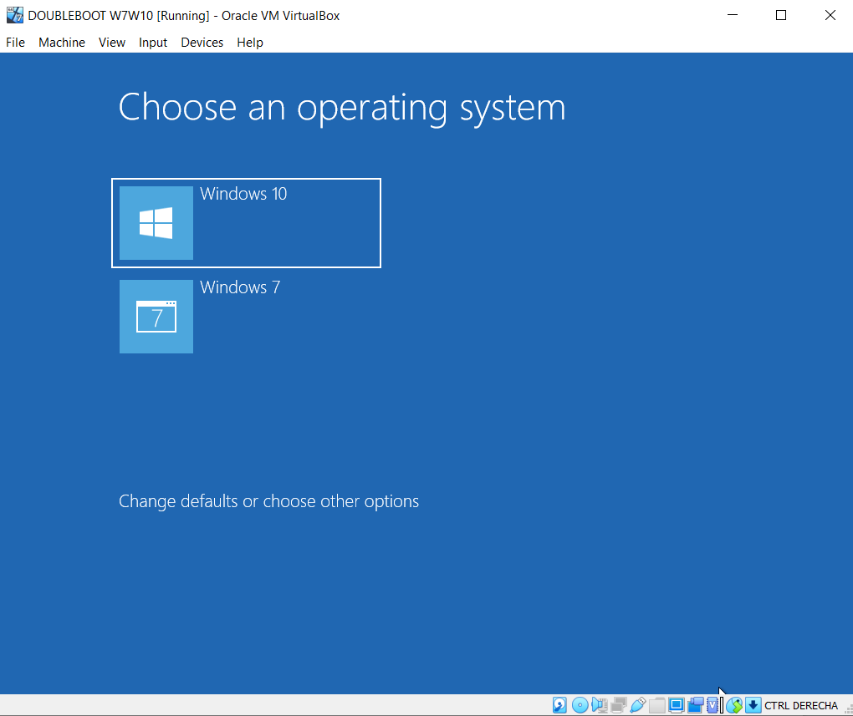
In order to have Windows 7 as the default operating system wich wil boot after 5 seconds unless Windows 10 is manually selected:
We can select the time in the option change the timer how is showed in the picture below:

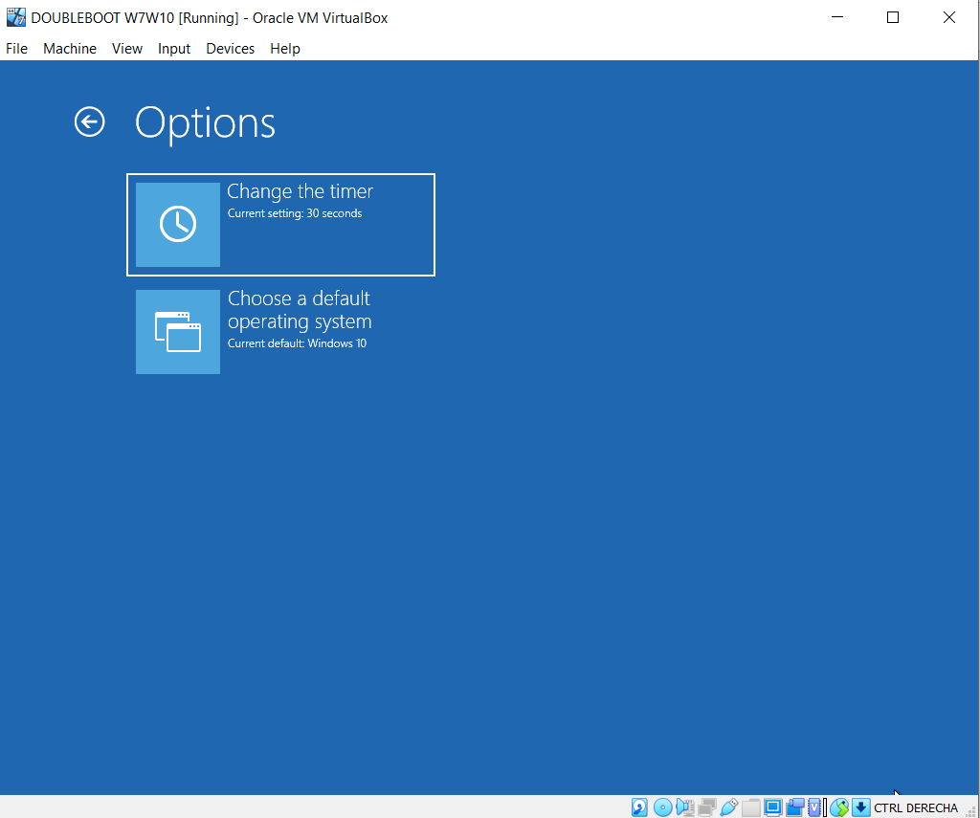
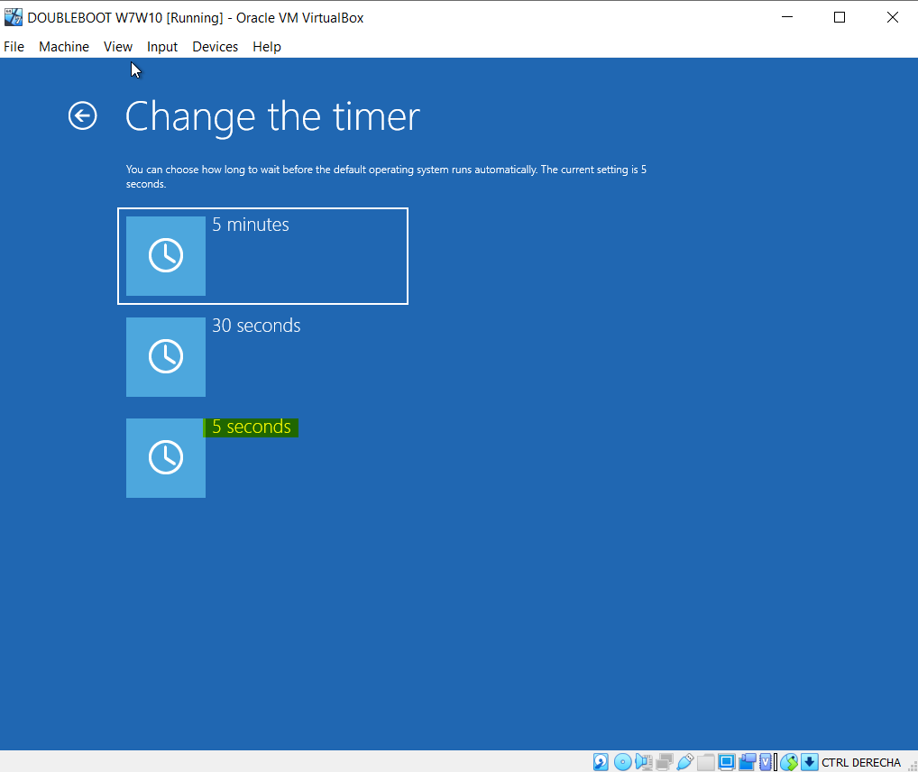

To change the default operating system we will select the option that is showed in the picture below:
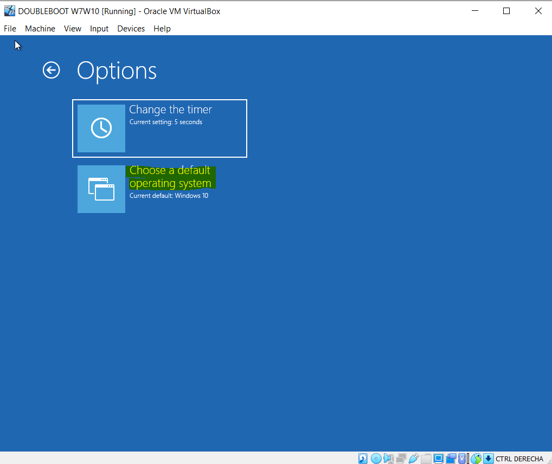
Finally the configuration is done:
